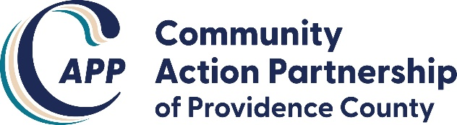
CAPP Board of Directors Meeting
November 18, 2020, 6-8pm
Board Members Present: Patricia, Paul, Jackie, Koren, Tarshire, Phareth, Thomas, Jenny, Ana
CAPP Staff Present: Rilwan, Norma, Gianna
Guest Presenter: Chuck Gordon 6-7 pm
_____________________________________________________________________________________
Meeting called to order at 6:09 pm
Patricia read the Mission Statement
Paul motioned to approve meeting agenda, Thomas seconded
Paul motioned to approve October’s meeting minutes, Phareth seconded
Fund Development Presentation – Chuck Gordon
- Why pursue philanthropy?
  - Leverage resources
  - Pursue funding – provide flexibility
  - Diversify – decrease reliance on income
You need to know the additional needs of programs – realistically, how much money is needed?
Multiyear commitments from donors = sustainability
- Build a base of multiyear supporters
- Leverage RI wealth market
- Attract support from Providence’s corporations and foundations
- Build capacity/capability/expectations

80% focus on Strategy 20% focus on Retail
- Planned giving - Events
- Major leadership
- Corporate partners
Excel at the basics:
Recruitment of community connectors
Build a community of mission, align investors
Engage board leadership
Identify a select group of business and community leaders, determine who volunteer leaders are

Foundation List
Core Individual Leadership Giving Program
Engage board leadership
Hire dedicated development staff, create a culture of philanthropy

Board members were asked to make a list of connectors/donors
Challenges:
- Recognition: Who are we? What do we do?
- Multiservices -> Specific services
Rilwan is meeting with Governor Raimondo to directly petition for money for CAA’s in Rhode Island
Chuck committed to put in a call to Citizen’s Bank Charitable Giving program
Presentation ended at 7:10 pm
Paul motioned to enter Executive Session, Phareth seconded
CAPP Staff allowed to remain on the call for ES
Regarding the search for a new building, the RI Indian Council at 807 Broad Street has become a possibility
The city still has not given CAPP a lease for the building on Hartford Avenue and Rilwan has zero confidence that they will sell it to CAPP for $1, which was the previous understanding. Meanwhile, CAPP has made many capital improvements to the property including touchless fixtures in bathrooms
State CARES Act money is still delayed, Rilwan will speak with the Governor about this
CAPP conducted a Community Needs Assessment, received over 1000 responses.
Requests for baby formula, warm clothes and coats stood out. CAPP is looking to provide coats to residents
105K CDBG housing funding is regulated by HUD. Regulations/guidelines were changed to be more restrictive and invoices for rental/mortgage assistance are being rejected. Cannot apply to rent/mortgage already in arrears
Paul motioned to leave Executive Session, Tarshire seconded
Paul motioned to approve development plan, Tarshire seconded
Board members asked to donate an amount significant to them and to return signed Conflict of Interest and Code of Ethics forms to Gianna
PLTI report from Koren:
PLTI alumni association was at the CAPP food pantry November 7th to clean and organize, will be back there on November 21st again. Board members are invited to join them there but must sign up via link sent at the meeting to maintain social distance guidelines.
Staff met with medical benefits provider, there is a 1% increase to cost of benefits
Paul motioned to adjourn the meeting, Tarshire seconded
Meeting adjourned at 8:17 pm

