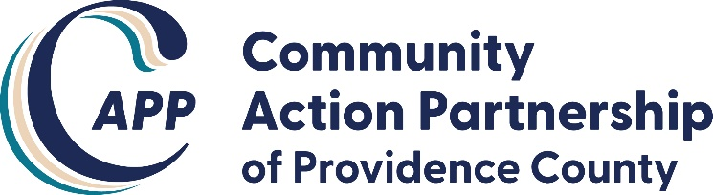
AGENDA
CAPP Board of Directors Meeting
January 13, 2021 Virtual (Zoom) 6:00pm – 8:00pm

MISSION STATEMENT
CAPP, working in partnership with the community, provides culturally competent supportive services and programs to Providence County residents in need to promote their achievement of economic self-sufficiency.

I. Meeting Call to Order, Roll Call, Recite CAPP Mission Statement
II. Approval of December 2020 Meeting Minutes
III. Review of Financial Statements and Finance Committee report out
IV. PLTI Alumni report, if any (Koren)
V. Executive Director Report and COVID-19 Updates
VI. Adjournment

